SUSPECTED CANCER REFERRAL FORM: BREAST

Date of decision  to refer: |  | Date referral received at Trust:

 | Trust name(s) | Email for referral
 | Ashford and St. Peter’s NHS Foundation Trust | Fax: 0800 9234668  Email: twrasph@nhs.net
 | Frimley Health NHS Foundation Trust | Fax: 01276 604506
 | Royal Surrey County Hospital NHS Foundation Trust | Fax: 01483 464848​  Email: rsc-tr.TWWAppts@nhs.net
 | Surrey and Sussex Healthcare NHS Trust | Fax: 01737 231733

Patient details
SURNAME: | FIRST NAME: |  | TITLE:
GENDER: | DOB: |  | NHS NUMBER:
ETHNICITY: | LANGUAGE:
INTERPRETER REQUIRED: | TRANSPORT REQUIRED:
PATIENT ADDRESS: |  |  | POSTCODE:
CONTACT DETAILS: HOME: |  | MOBILE: | EMAIL:

GP practice details
USUAL GP NAME:
PRACTICE NAME:
PRACTICE ADDRESS: |  | PRACTICE CODE:
DIRECT LINE TO THE PRACTICE (BYPASS):
MAIN: | FAX: | EMAIL:

Referring clinician:

Patient engagement and availability
I confirm the following:
I have discussed the possibility that the diagnosis may be cancer
I have provided the patient with a suspected cancer referral leaflet
I have informed the patient that the appointment will be within the next two weeks & attendance is advised
Please note any dates the patient is NOT available for an appointment in the next 2 weeks.

Patient’s WHO performance status
 | Grade | Explanation of activity
 | 0 | Fully active, able to carry on all pre-disease performance without restriction.
 | 1 | Restricted in physically strenuous activity but ambulatory and able to carry out work of a light or sedentary nature, e.g., light house work, office work.
 | 2 | Ambulatory and capable of all selfcare but unable to carry out any work activities. Up and about more than 50% of waking hours.
 | 3 | Capable of only limited selfcare, confined to bed or chair more than 50% of waking hours.
 | 4 | Completely disabled. Cannot carry on any selfcare. Totally confined to bed or chair.

Affected side
Axillary R L

Upper Outer Quadrant R L

Lower Outer Quadrant R L

Upper Inner Quadrant R L

Lower Inner Quadrant R L

Examination findings

Please mark the breast diagram below and/or provide a clinical description below it.

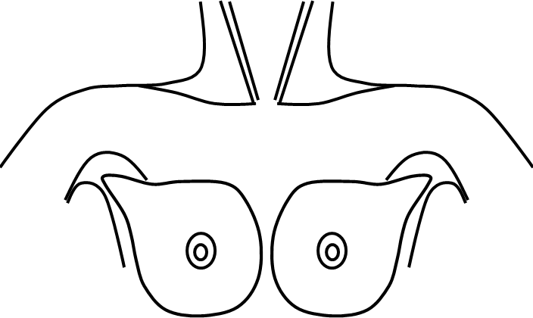
HOW TO MARK THE DIAGRAM
Place the mouse cursor over the diagram at the position of the lesion. Click the left mouse button. Use the keyboard to mark the diagram (X marks the lesion). Use the mouse or arrow keys to move left or right or to adjacent lines. Please do not press the <ENTER> key as it may cause alignment problems with your markers.

Clinical description (including site, size, consistency and axillary involvement):

Signs/symptoms:

Relevant family history, please specify relationship and age at diagnosis:

Previous breast imaging? If so, please give details:

Criteria for an appointment with a specialist within two weeks
Aged ≥30yr and
Unexplained breast lump with or without pain
Unexplained lump in the axilla (consider)

Aged ≥50yr and one nipple affected by
Discharge
Retraction
Other changes of concern

Any age and
Skin changes that suggest cancer (consider)
(tethering; fixation; ulceration; peau d’orange; inflammation that does not settle after one course of antibiotics; non-responsive eczema)

Non-Urgent (please be aware that the patients will be seen in the two week wait breast pathway)

Aged ≤30yr and
Unexplained breast lump with or without pain (consider)

Aged ≥ 35yr and
Abscess or breast inflammation remains after treatment*
* from SIGN guidance

Investigations
Please ensure the following recent results are available:

Blood test (less than 8 weeks old):
eGFR result _________________Date ____________ Or date of test ____________

Free text box for additional clinical information/referral letter:

If this case has been discussed with the secondary care clinical team, please specify with whom, when and advice given:
Please use this area to autopopulate a patient summary: to include recent consultations, current diagnoses; past medical history; recent investigations; recent blood test results; medication; any other fields which might be helpful to secondary care.

Further information and guidance

Useful websites:

CRUK main | CRUK learning | e-CDS
Macmillan | Macmillan learning | Genetics and Family History
Map of Medicine | NICE | Q-Cancer

